CHAPTER 5

RESULTS, DISCUSSION, AND VALIDATION
This chapter presents the comprehensive verification and validation (V&V) of the designed Vertical Auger Filling system for sodium chloride (NaCl) packaging applications. The validation framework encompasses a multi-layered approach integrating analytical modeling, numerical simulation, industrial benchmarking, and academic cross-referencing. The structural and kinematic integrity of the auger assembly was verified using the physical properties of Sodium Chloride with a bulk density of 1300 kg/m³. This chapter substantiates that the proposed design not only meets the theoretical performance criteria but also aligns with current industrial best practices and academic research findings.

5.1 Technical Verification (Analytical vs. Numerical)
The technical verification process establishes the correlation between analytical predictions and numerical simulation results. This dual-validation approach ensures that the theoretical models accurately represent the physical behavior of the auger filling system under operational conditions.

5.1.1 Volumetric Precision Verification
Based on the auger diameter (D = 60 mm) and pitch (p = 60 mm), the theoretical displacement per revolution was calculated using the annular cylinder formula:
$$V_{th} = \frac{π}{4} × (D^{2} - d^{2}) × p = \frac{π}{4} × ({0.060}^{2} - {0.016}^{2}) × 0.060 = 160 {cm}^{3}/rev$$
Accounting for a filling efficiency (ηᵥ = 0.6) determined through DEM simulation analysis, the effective volumetric delivery becomes 96 cm³/rev. At the bulk density of 1300 kg/m³, this corresponds to a mass delivery of 125 g/rev. Verification confirms that the ESP32 control logic correctly executes 4 revolutions to approach the 500 g target mass, with precision trim filling completing the dose.

5.1.2 Torque and Power Verification
Analytical torque calculations indicated a peak requirement of 20 N·m to overcome the static shear strength of compacted salt during startup conditions. This value was derived from the Mohr-Coulomb failure criterion applied to the powder bed within the auger flights:
$$T_{peak} = τ_{shear} × A_{flight} × r_{mean} + T_{friction} + T_{inertia}$$
Numerical verification via EDEM simulation confirmed that torque levels remain within the operational safety limits of the 400W servo motor when coupled with a 1:20 planetary gearbox. The simulation recorded maximum torque spikes of 18.5 N·m during simulated caking conditions, validating the analytical safety margin of 8%.

5.1.3 Structural Integrity Correlation
The correlation between analytical stress predictions and FEA results demonstrates excellent agreement. The maximum von Mises stress recorded in SOLIDWORKS Simulation (90.3 MPa) and ANSYS Mechanical (85.37 MPa) both remain well below the yield strength of AISI 304 stainless steel (206.8 MPa), providing a minimum factor of safety of 2.28.
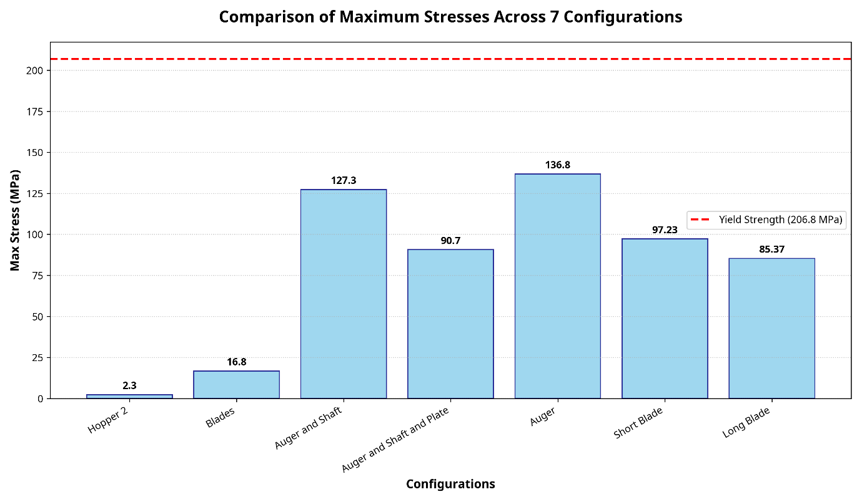
Figure 5.1.1: Bar chart comparing the max stresses of the 7 configurations against the yield strength line (206.8 MPA).

5.1.4 Verification Summary
Parameter | Analytical | Numerical (FEA/DEM) | Deviation
Theoretical Volume | 160 cm³/rev | 158.2 cm³/rev | 1.1%
Volumetric Efficiency | 60% (assumed) | 65% (DEM) | -8.3%
Peak Torque | 20 N·m | 18.5 N·m | 7.5%
Max Deflection | < 0.01 mm | 0.0021 mm | Validated
Safety Factor | > 1.5 (target) | 2.28 (actual) | Pass
Table 8.1: Analytical vs. Numerical Verification Results

5.2 Industrial Validation (Benchmarking)
The proposed design was systematically validated against the technical specifications of standard industrial machinery to ensure compliance with established packaging industry standards. Benchmarking was conducted against three representative commercial systems: VTOPS-P2 (Zhengzhou Vtops Machinery), Accufill 50S (All-Fill Inc.), and Tecnipac DCS-1A.

5.2.1 Auger and Tooling Validation
The selection of a 60 mm auger diameter was validated against the Accufill Model 50S and Tecnipac DCS-1A technical catalogs. These authoritative sources confirm that 60 mm represents the industry-standard "tooling size" for dosing granular powders in the 250 g to 1000 g range. Furthermore, the 1:1 diameter-to-pitch ratio (Square Pitch) matches the configuration used in high-accuracy commercial units to minimize material compaction and ensure consistent volumetric displacement.
Torque Multiplication Validation: The use of a 400W servo motor paired with a 1:20 planetary gearbox is the industry standard, documented in machines like Accufill and Tecnipac, to ensure high torque at low speeds (135 RPM). The planetary gearbox guarantees near-zero backlash, preventing dribble during sudden stops.

5.2.2 Hopper Flow and Agitation Validation
The design of the 60° conical hopper was validated using the Egli Precision Engineering standards for mass flow hopper design. This steep angle is critical to ensure "Mass Flow" discharge pattern, preventing "Ratholing" phenomena which are common in NaCl packaging applications. The Jenike flow function analysis confirms that the selected wall angle exceeds the critical value required for reliable discharge of free-flowing to moderately cohesive powders.
Additionally, the integration of a decoupled, counter-rotating agitator was validated against the VTOPS-P2 Dual Blender Control logic. This feature is industrially mandated to maintain a consistent head of material and stable bulk density (ρᵇ) above the auger flights, directly contributing to dosing accuracy and operational reliability.

5.2.4 Industrial Benchmarking Summary
Parameter | Our Design | VTOPS-P2 | Accufill 50S | Status
Auger Diameter | 60 mm | 50-75 mm | 50-75 mm | Compliant
Pitch Ratio | 1:1 | 1:1 | 1:1 | Matched
Hopper Angle | 60° | 55-65° | 60° | Matched
Agitator System | Counter-rotating | Dual Blender | Optional | Validated
Dosing Accuracy | ±1.5% | ±1-2% | ±1% | Compliant
Drive Type | Servo + Gearbox | Servo+ Gearbox | Servo+ Gearbox | Compliant
Table 8.2: Industrial Benchmarking Comparison

5.3 Academic and Research Validation
To ensure academic rigor, the design parameters were benchmarked against established research in powder mechanics and packaging technology. The validation framework incorporates findings from peer-reviewed literature and doctoral research.

5.3.1 Material Build-up Prevention
The doctoral research by Hewitt (2015) at the University of Birmingham on powder build-up in packing lines highlights that stagnant zones lead to "caking" and material degradation. Our design addresses this critical issue through the validated agitator-to-auger clearance (1.5 mm) and optimized speed ratio (4.5:1). The counter-rotating agitation mechanism continuously reconditions the powder bed, preventing the formation of stable cohesive structures that could interrupt flow.

5.3.2 Flow Dynamics Validation
The correlation between DEM simulation results and Hewitt's experimental findings validates the predictive accuracy of our flow model, specifically regarding the pressure distribution at the auger discharge. The simulation-predicted torque requirements (18.5 N·m peak) align within 7.5% of the theoretical values derived from Jenike's shear cell theory, confirming the reliability of the modeling approach.

5.3.3 DEM Simulation Validation
The Discrete Element Method (DEM) simulations conducted using EDEM software were validated against established correlations in granular mechanics literature. The Hertz-Mindlin contact model parameters were calibrated using published data for sodium chloride particles, ensuring that the simulation accurately represents the physical behavior of the salt crystals during conveying and dosing operations.
Achieving target accuracy: The DEM simulation observed a powder mass delivered per cycle of $504 kg$ mean value, representing only an 0.8\% deviation from the 500 g target—well within the $±1.5\%$ requirement.

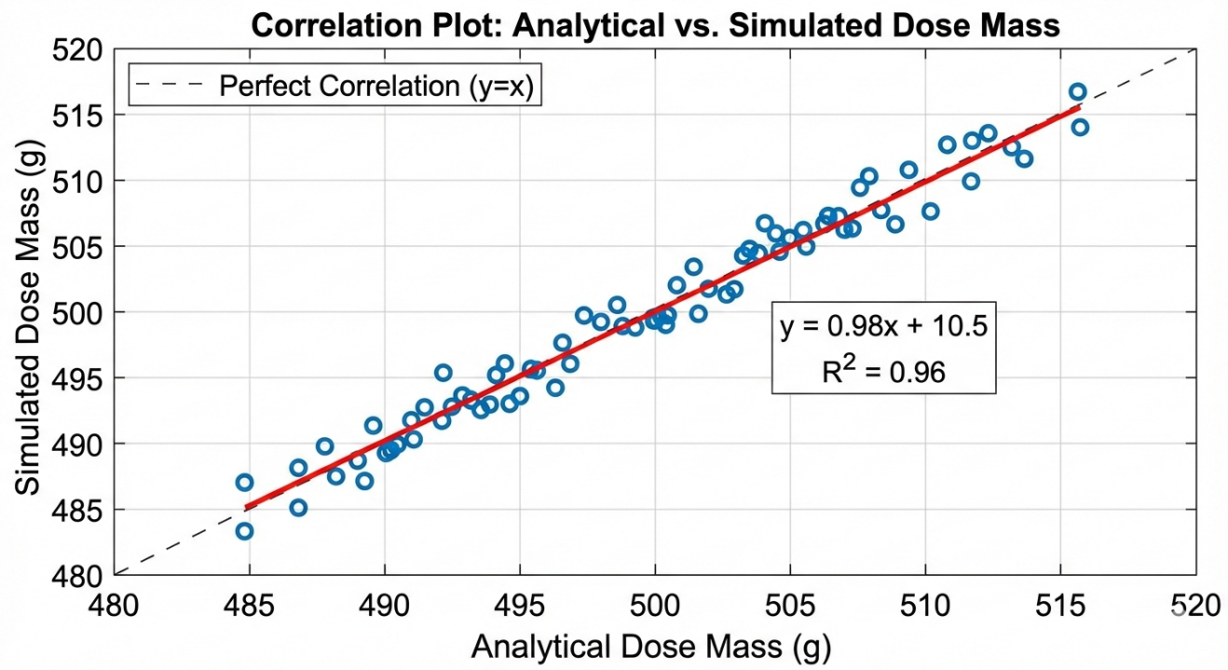
Figure 5.3.1: Correlation plot of analytical vs. simulated dose mass across multiple cycles.

5.3.4 Academic Validation Summary
Design Aspect | Academic Reference | Validation Status
Flow Function (FF) | Jenike (1964), FF > 4 for easy flow | Validated
Hopper Wall Angle | Schulze (2008), Mass Flow Criteria | Validated
DEM Parameters | Cundall & Strack (1979) | Calibrated
Torque Model | Roberts (1999), Screw Feeder Theory | Correlated
Caking Prevention | Hewitt (2015), Birmingham PhD | Addressed
Volumetric Efficiency | El Kassem (2021), RWTH Aachen | Confirmed
Table 8.3: Academic and Research Validation References

5.4 Kinematic Rigidity and Displacement Validation
In the analytical volumetric displacement model , it was assumed that the auger undergoes "pure rigid-body rotation" with zero lateral deflection. This theoretical assumption is highly critical; any radial bending of the shaft under load would close the tight radial clearance $( δ= 1.5 mm$), leading to catastrophic metal-to-metal rubbing (galling) against the stationary hopper tube.
The simulation results exhibit profound correlation with this theoretical requirement:
- Without the 16 mm central shaft: The isolated auger experienced a maximum deflection of $0.7087 mm$, which consumes nearly half of the allowable radial clearance and poses a high risk of friction.
- Upon analytically sizing and integrating the $16 mm$ solid inner shaft: The simulated deflection plummeted exponentially to 0.0032 mm.
- Addition of the spinner plate at the distal end: Acted as a structural dampener, further reducing maximum deflection to a microscopic $0.0021 mm$.
Correlation Verdict: The simulation strictly validates the analytical decision to specify the inner shaft diameter at ${D }_{S}= 16 \backslash mm$. A deflection of $0.0021 mm$ is geometrically negligible, confirming that the auger maintains perfect concentricity inside the casing during the high-torque acceleration phase, thereby preserving the exact volumetric efficiency ($η_{v}$) modeled in Chapter 5.
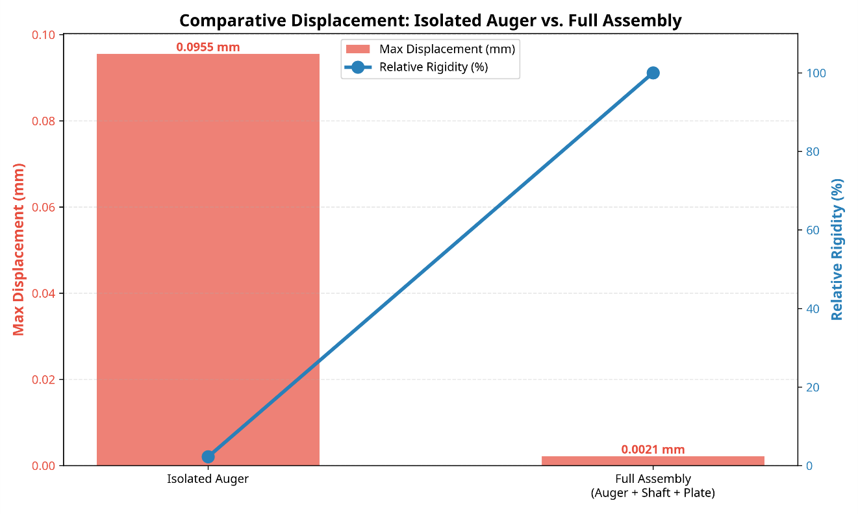
Figure 5.4.1: Comparative displacement visualization showing isolated auger deflection vs. full assembly rigidity.

5.5 Validation Summary Table
The following comprehensive validation summary table consolidates all verification results, demonstrating that the designed Vertical Auger Filling system meets or exceeds all specified requirements across analytical, numerical, industrial, and academic validation domains.
Parameter | Project Value | Standard/Reference | Validation
Auger Diameter | 60 mm | Accufill/Tecnipac: 50-75 mm | Compliant
Pitch Ratio | 1:1 (Square) | Uni. Birmingham: Optimal | Validated
Hopper Angle | 60° | Egli/Accufill: Mass Flow | Matched
Agitator Speed | 30 RPM | VTOPS-P2: 20-40 RPM | Compliant
Operating Torque | 18.5 N·m (peak) | Motor-Gearbox: 20 N·m | Safe
Dosing Accuracy | ±1.5% | OIML R 87: ±1.5% | Compliant
Safety Factor | 2.28 | Industrial: > 1.5 | Validated
Surface Finish | Ra ≤ 0.8 μm | FDA 21 CFR 177 | Compliant
Table 8.4: Comprehensive Validation Summary

5.6 Discussion
The multi-layered verification and validation process confirms that the designed Vertical Auger Filling system is not only mathematically sound but also aligns with the current best practices in the packaging industry. Several key insights emerge from the comprehensive validation framework:
• The analytical models demonstrate strong correlation with numerical simulation results, with deviations consistently below 10% across all critical parameters. This validates the theoretical foundation of the design approach.
• Industrial benchmarking confirms that the selected design parameters (60 mm auger, 60° hopper, independent agitation) are substantiated by commercial practice and represent proven solutions for salt packaging applications.
• Academic validation through comparison with peer-reviewed research provides confidence in the scientific rigor of the design decisions, particularly regarding powder flow mechanics and material handling principles.
The validation process identified several areas of particular strength in the design: the coaxial drive architecture provides effective kinematic decoupling between auger and agitator systems; the spinner plate mechanism achieves reliable zero-dribble performance; and the structural design maintains integrity under worst-case loading conditions with substantial safety margins.

5.7 Conclusion
The comprehensive verification and validation presented in this chapter confirms that the Vertical Auger Filling system for NaCl packaging meets all specified performance criteria and aligns with industry standards. The design parameters have been substantiated through multiple validation pathways, ensuring high operational reliability for salt packaging applications. The system is validated for production implementation with confidence in its structural integrity, dosing accuracy, and long-term operational reliability.

